D2L Login URL:
http://d2l.arizona.edu

Course Request URL:
http://d2l.arizona.edu/csr
You must be listed as the primary instructor in UAccess in order to request a D2L course site. If you are not contact department administrator.
How to Get Help:
Email: d2l@email.arizona.edu
Phone: 626-6804 (8:00 am – 5:00 pm M –F)
Help Pages: help.d2l.arizona.edu
Open Hours: Mondays 12:00 pm – 3:00 pm
Tuesdays: 12:00 pm – 3:00 pm
Wednesdays: 10:00 am – 1:00 pm
Thursdays: 10:00 am – 1:00 pm
By appointment

Roles: What you can and cannot do in a course
Instructor Role: A participant with this role has FULL access (create, edit, and view) to ALL areas of a course site. This role can copy course materials from one D2L course site to another. This is the ONLY role that can enroll and unenroll participants for a course site (with the exception of students).

TA All Sections Role: A participant with this role can create, edit, and view in most areas of a course site. This role cannot delete anything in any area of a D2L course site. While this role can view and enter data in the Grades tool, it CANNOT create, edit, or delete grade categories or items.

TA Specific Sections Role: A participant with this role can create, edit, and view in most areas of a course site. This role cannot delete anything in any area of a D2L course site. This role can ONLY view and enter data for grade-related items for sections specified by the instructor.

Students cannot be manually enrolled. They are enrolled automatically from class lists in UAccess.

New Instructor Workshops
Wednesday August 20 10:00 – 11:00 am
Tuesday August 26 12:00 – 1:00 pm

Registration: http://oia.arizona.edu/professional-development

Where to Find the Office of Instruction and Assessment (OIA):
On the web: http://oia.arizona.edu
In Person:
Office of Instruction and Assessment in Manuel Pacheco Integrated Learning Center
1500 East University, Building 70

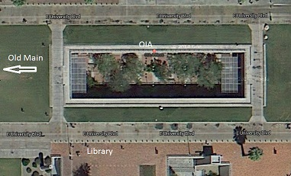

In the hole in the ground just north of the main library
Office of Instruction and Assessment Services:
Program Assessment and Evaluation
Instructional Support and Development
Assistance with instructional design, classroom management, student engagement and assessment
Instructional Technologies Support – D2L
Multimedia Solutions
Development of multimedia class materials for instruction

Details of OIA’s services can be found on our web site (see above)

