


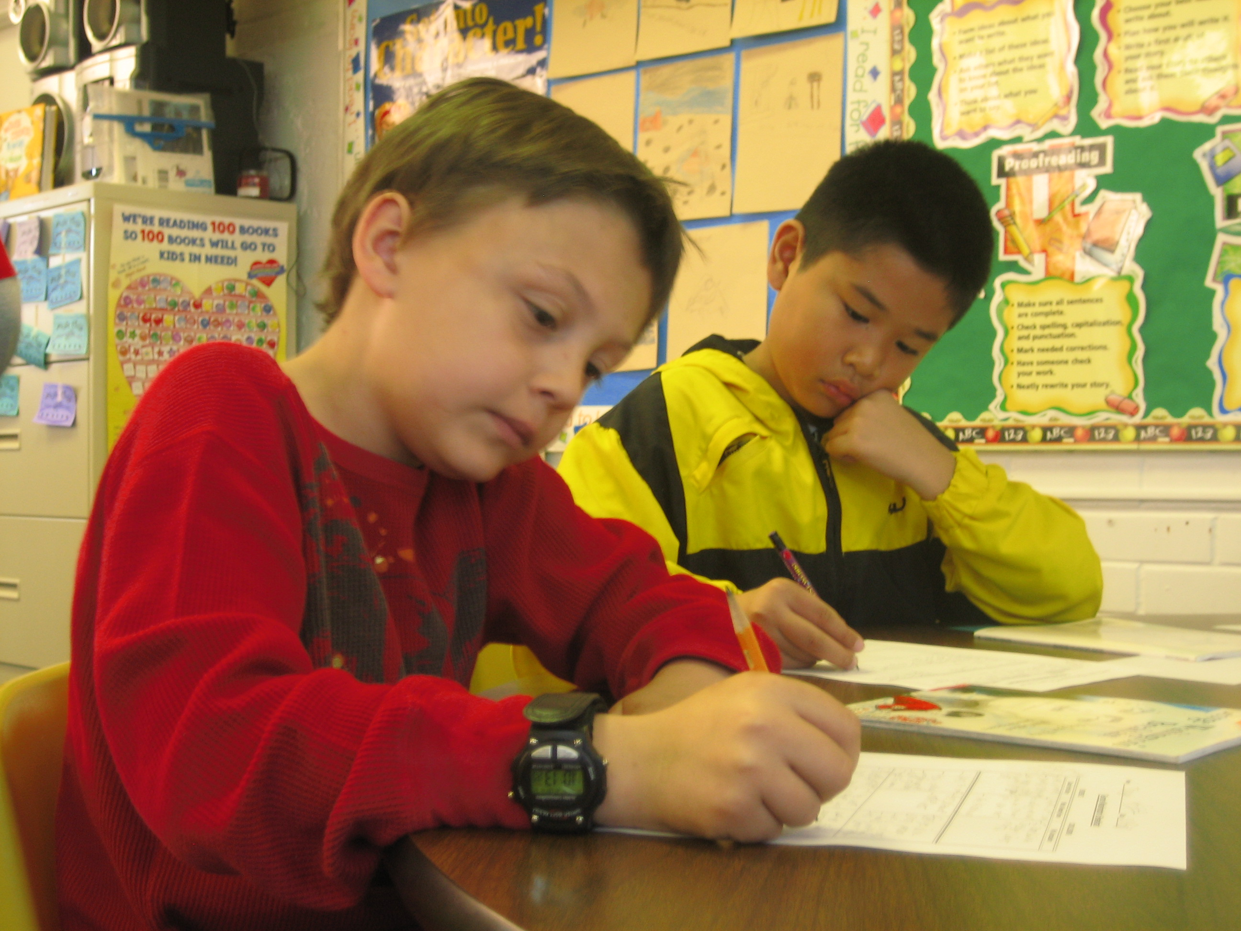

Teacher Candidate Guidebook



Fall 2018 Spring 2019

Introduction

The University of Arizona, College of Education is committed to providing our students with a positive, professional, and practical student teaching experience. University supervisors, along with cooperating/mentor teachers, are the professionals who work with student teachers to help them have a successful student teaching experience which will encourage them to enter the education profession as enthusiastic and effective teachers who focus on the right work with students.

This edition of the “Teacher Candidate Guidebook” is meant to be a resource guide with practical information to help student teachers and cooperating/mentor teachers understand their roles and responsibilities. The University of Arizona, College of Education has many different models of Student Teaching. The Student Teacher Guidebook is not meant to be comprehensive. We will be revising information as we receive your feedback and updated information. It will be the student teacher, cooperating/mentor teacher, and University supervisor’s responsibility to obtain any additional information they feel is necessary to be successful.

As the Director of Field Experiences, I want to welcome you to the University of Arizona, College of Education student teaching semester and thank you in advance for your commitment to make the Teacher Preparation Program and specifically the Student Teaching Experience, a positive, professional and practical experience, which will prepare teachers for future success in the classroom.




Maggie Shafer
Director of Field Experiences
Phone: (520) 621-5908
Email: margaretshafer@email.arizona.edu

Table of Contents

- University of Arizona Teacher Preparation Programs 1-5
Professional Standards
University of Arizona Teacher Preparation Professional
Program Standards
- InTASC Professional Teacher Standards
- NETS*T National Educational Technology Standards
- Professional Growth Plan

II. Student Teacher Information 6-7
Application Process and Eligibility for Student Teaching
  - Eligibility Requirements
  - Policy Regarding Placements
  - Disability Accommodations
  - Nondiscrimination and Anti-Harassment Policy
Placement Guidelines for Student Teachers 8
Student Teaching Agreement Form 9
Calendar Information 10
- Student Teacher Semester Requirements
- Substitute Teaching
- Semester Calendar Guidelines
Required Daily Hours 11
- Required Daily Hours
- Absences

III. Student Teacher Responsibility Schedule 12-18
Responsibility Schedule Information
- Orientation
- Assuming Partial Responsibility
- Full Responsibility
- Transfer of Responsibility
- Responsibility Schedule
- Student Teaching Requirements

IV. Cooperating Teacher Information 19
Cooperating/Mentor Teacher Information

- Selection Process
- Qualifications
Cooperating/Mentor Teacher Roles and Responsibilities 20
Cooperating/Mentor Teacher Feedback 21-22
- Evaluation as a Continuous Process
- Daily Conferences
- Weekly Conferences
- Video Taping
- E-mail
- Conferences with the University Supervisor
Compensation for Cooperating/Mentor Teachers 23-24
- Student Teaching Mentor Teacher Compensation Record

- University Supervisor Information 25
University Supervisors
- Qualifications
- Overview of Requirements
Student Teacher Orientation Meeting 26-28
- Initial Visit To The Classroom
- Classroom Observations
- Scheduling
- Amount of Time
- Weekly Contacts with Student Teachers
- Seminars
Policy for Student Teacher Dismissal/Reassignment 29

- Assessment of Student Teacher Performance 30
Assessment of Student Teacher Performance
- Grading
- Required Assessments
Midterm and Final Conference Guidelines 31
- Scheduling
- Midterm and Final Assessment Form
- Procedures for Completing University of Arizona
Assessment Forms
Student Teaching Time Record 32-33
Student Teacher Assessment 34-38
Midterm-Final Scoring Rubric 39-46
Student Teacher Portfolio Criteria 47-48

University of Arizona
Teacher Preparation Programs Professional Standards

Office of Field Experiences


The University of Arizona
Teacher Preparation Programs Professional Standards

Overview

The University of Arizona has a responsibility to the educational community to ensure that individuals, who are recommended to the State of Arizona for teaching certification, are worthy to join the teaching profession. In order to communicate the expectations for students, the faculty has adopted the InTASC Standards, which the Arizona Department of Education (ADE) will be using as professional teaching standards. “The Interstate Teacher Assessment and Support Consortium (InTASC) is a consortium of state education agencies and national educational organizations dedicated to the reform of the preparation, licensing, and on-going professional development of teachers. Its work is guided by one basic premise: An effective teacher must be able to integrate content knowledge with the specific strengths and needs of students to assure that all students learn and perform at high levels.” More information on the InTASC Standards can be found at: http://www.ccsso.org/Documents/2011/InTASC_Model_Core_Teaching_Standards_2011.pdf. In addition, the University of Arizona Teacher Preparation Program Professional Standards include the International Society for Technology in Education Teacher Standards created by the International Society for Technology in Education (ISTE NETST). More information can be found at: http://www.iste.org/Libraries/PDFs/NETS-T_Standards.sflb.ashx
Finally, the University of Arizona Teacher Preparation Professional Standards include additional requirements specific to our programs.

Upon admission to a Teacher Preparation Program (TPP), students receive a copy of the TPP Professional Standards and the related referral forms. The TPP Professional Standards are the expectations for University of Arizona students who plan to become teachers. All students in any TPP at The University of Arizona are expected to demonstrate that they are prepared to teach children and youth. This preparation results from the combination of successful completion of coursework and display of important human characteristics which teachers should possess. Because the TPP Professional Standards are used throughout the certification programs from admission to graduation, some criteria will be more relevant when students are in fieldwork and some when students are completing coursework. The areas that the TPP Professional Standards address are (I) Learner and Learning, (II) Content Knowledge, (III) Instructional Practice, (IV) Professional Responsibility, (V) Educational Technology, and (VI) additional academic and professional requirements specific to the University of Arizona.
UA students, faculty, staff, and supervisors, as well as cooperating teachers involved with teacher preparation programs are provided copies of the TPP Professional Standards. As needed or required by each TPP, both UA and field-based professional educators may initiate the form for “Identification of Students Exhibiting Outstanding Performance” and the form for “Identification of Students with Performance Concerns.” These referral forms allow the programs to identify students who display outstanding knowledge, skills, and dispositions that deserve recognition. The procedure is also used to identify students whose performance is raising concerns about their ability to successfully complete the program. Students with performance concerns may be placed on a Professional Growth Plan, with completion of the program dependent on successful adherence to the plan. Student appeals of this process must follow university policy.
1
1

Professional Standards

I. The Learner and Learning
- InTASC Standard #1: Learner Development. The teacher understands how learners grow and develop, recognizing that patterns of learning and development vary individually within and across the cognitive, linguistic, social, emotional, and physical areas, and designs and implements developmentally appropriate and challenging learning experiences.
- InTASC Standard #2: Learning Differences. The teacher uses understanding of individual differences and diverse cultures and communities to ensure inclusive learning environments that enable each learner to meet high standards.
- InTASC Standard #3: Learning Environments. The teacher works with others to create environments that support individual and collaborative learning, and that encourage positive social interaction, active engagement in learning, and self-motivation.

II. Content
- InTASC Standard #4: Content Knowledge. The teacher understands the central concepts, tools of inquiry, and structures of the discipline(s) he or she teaches and creates learning experiences that make the discipline accessible and meaningful for learners to assure mastery of the content.
- InTASC Standard #5: Application of Content. The teacher understands how to connect concepts and use differing perspectives to engage learners in critical thinking, creativity, and collaborative problem solving related to authentic local and global issues.

III. Instructional Practice
- InTASC Standard #6: Assessment. The teacher understands and uses multiple methods of assessment to engage learners in their own growth, to monitor learner progress, and to guide the teacher’s and learner’s decision making.
- InTASC Standard #7: Planning for Instruction. The teacher plans instruction that supports every student in meeting rigorous learning goals by drawing upon knowledge of content areas, curriculum, cross-disciplinary skills, and pedagogy, as well as knowledge of learners and the community context.
- InTASC Standard #8: Instructional Strategies. The teacher understands and uses a variety of instructional strategies to encourage learners to develop deep understanding of content areas and their connections, and to build skills to apply knowledge in meaningful ways.

IV. Professional Responsibility
- InTASC Standard #9: Professional Learning and Ethical Practice. The teacher engages in ongoing professional learning and uses evidence to continually evaluate his/her practice,
- particularly the effects of his/her choices and actions on others (learners, families, other professionals, and the community), and adapts practice to meet the needs of each learner.
- InTASC Standard #10: Leadership and Collaboration. The teacher seeks appropriate leadership roles and opportunities to take responsibility for student learning, to collaborate with learners, families, colleagues, other school professionals, and community members to ensure learner growth, and to advance the profession.
2
2

V. Educational Technology
- NETST #1: Facilitate and Inspire Student Learning. Teachers use their knowledge of subject matter, teaching and learning, and technology to facilitate experiences that advance student learning, creativity, and innovation in both face-to-face and virtual environments.
- NETST #2: Design and Develop Digital Age Learning Experiences and Assessments. Teachers design, develop, and evaluate authentic learning experiences and assessment incorporating contemporary tools and resources to maximize content learning in context and to develop the knowledge, skills and attitudes identified in the NETSS.
- NETST #3: Model Digital Age Work and Learning. Teachers exhibit knowledge, skills and work processes representative of an innovative professional in a global and digital society.
- NETST #4: Promote and Model Digital Citizenship and Responsibility. Teachers understand local and global societal issues and responsibilities in an evolving digital culture and exhibit legal and ethical behavior in their professional practices.
- NETST #5: Engage in Professional Growth and Leadership. Teachers continuously improve their professional practice, model lifelong learning, and exhibit leadership in their school and professional community by promoting and demonstrating the effective use of digital tools and resources.

- University of Arizona Requirements for Teacher Candidates
In addition to the InTASC and ISTE NETST Standards, teacher candidates at the University of Arizona demonstrate a commitment to their academic program and to education by:
- attending, being on time, and being prepared for scheduled classes and field experiences;
- having a professional appearance;
- communicating professionally and respectfully orally and in writing with and about peers, colleagues, instructors, K-12 students, teachers, administrators, families, and community members, including all forms of social media;
- looking beyond self and respecting differences of race, ethnicity, language, social class, national allegiance, cultural heritage, disability or perceived disability, gender, and sexual orientation;
- accepting and acting upon reasonable criticism;
- understanding and respecting others’ perspectives;
- questioning and testing their assumptions about teaching and learning;
- separating personal and professional issues;
- exhibiting their knowledge through inquiry, critical analysis, and synthesis of the subject;
- maintaining or exceeding the minimum grade point average in their respective programs: Elementary Education – 3.0 GPA

At any time during a teacher candidates progression through the elementary education program, should a teacher candidate exhibit the need for additional support in one or more areas, a professional growth plan is created to ensure that expectations are clearly stated and as a vehicle for extra support.

Below please find a sample of this plan.

3
3
UA Teacher Preparation Programs
PROFESSIONAL GROWTH PLAN

Student Name Date
_____ College of Education _____ College of Science
_____ College of Fine Arts _____ College of Agricultural & Life Sciences

Professional Growth Team Members: (Insert names of Program Director, Instructors, Mentor Teacher(s), University Supervisor(s), Site Coordinators, and/or Advisors as appropriate.)

STRENGTHS

CONCERNS

EXPECTATIONS
(Summarize any events that may have necessitated the creation of this growth plan.)

In order for ________________________(insert student name) to successfully complete__________________(insert course/field experience/internship/student teaching),s/he must meet all of the following expectations by ________________(insert date/year).

Standards of Concern  (within appropriate box below, insert references to specific standards that are not being met) | Changes & Expectations | Measure | Support
Content Knowledge
Learning & Learning
Instructional Practice
Positive Learning Environment
Families & Communities
Professionalism
University of Arizona Standards for Teacher Candidates

As an accredited teacher preparation program, we are required to monitor student progress. The intent is to ensure that graduates of the program demonstrate the professional knowledge and skills to be successful as teachers. To satisfactorily progress through the program, __________ (insert student name) must meet the expectations above.

In _______________insert date/year), _____________ (insert student name) and the team will discuss the _____________’s (insert student’s name) progress with regard to the expectations listed in this document and a decision will be made about whether the student will continue in the program.

At any time prior to or after the second scheduled meeting, if any of the members of the Professional Growth Team feel that the student is not fulfilling all of his/her responsibilities, or he/she is unable to meet the expectations required by this document, a meeting will be called to inform the student that he/she will not be able to continue in the program.
4
4

If the student is unable to complete the courses and field or meet the expectations described, the student must meet with the Program Director and schedule an advising appointment to discuss options for the future. The options may include but are not limited to:
- Petitioning to student teach in ___________ demonstrating that she has met all the requirements listed above.
- Petitioning to withdraw from current courses and re-taking courses the following semesters;
- Petitioning to withdraw from courses and petitioning for re-admittance to the program after documentation that areas of concerns have been addressed.
- Petitioning to withdraw from course/program and applying to an alternate program within the department.

If a petition is not submitted or is denied, the student will not pass the current course(s), will not continue in the program, may not be allowed to petition for re-admittance to the program, and as a result will not be recommended for certification.

SIGNATURES

Professional growth team member name & role Professional growth team member name & role

Professional growth team member name & role Professional growth team member name & role

I have read and been given a copy of this document. Any comments I have are attached.

_

Student Date

As of ___________________________________(Insert date/year), the student has successfully met the expectations delineated in this Professional Growth Plan.

Signatures
5

Professional Growth Plan

__________________________________________
Program Director



Student Teacher
Information

Office of Field Experiences

Application Process and Eligibility for Student Teaching

The application process for student teaching begins the semester before student teaching. Students are informed by site coordinators of upcoming important dates relating to the application process.

The first step in the process involves students attending an “Application Meeting” at their field based site. All application meetings are held at the Field Based Methods school sites. The meetings are held at various times to accommodate class schedules and also to allow time to answer questions in small group situations. Application meetings are held in September for spring semester student teaching and in January for fall semester student teaching. Students will receive an application packet/online information at the meeting and have the opportunity to ask questions.

The second step in the process is for the students to complete the online application and corresponding paperwork which includes a registrations form and a resumé. Some school districts may require additional paperwork. The application includes general information needed to place students in the best possible classroom situation which will assure a positive student teaching experience. The Office of Field Experiences works with the site coordinator to find the best placement for the teacher candidate. Placement preference is given to mentor teachers with whom the teacher candidate has done practicum work with in the past. In this way, stronger mentor/mentee relationships are forged. Additionally, the teacher candidate benefits from the previous understandings gained in the earlier placement and can begin teaching more fully earlier in the semester.

The third step may be required in the application process. A student may be required to meet with the Director of Field Experiences in the College of Education to discuss his/her application.

Eligibility is essential and confirmation of a 3.0 GPA will be required from the student’s academic advisor before the student teaching semester begins.
7
6
6

Eligibility Requirements
You must have a current valid Arizona State Department of Public Safety IVP fingerprint clearance card to be eligible to student teach.
More information can be obtained on the DPS website at http://www.azdps.gov/services/fingerprint/.

You must maintain a 3.0 GPA in your overall coursework and within your major to be eligible for student teaching.

Policy Regarding Placements
It is a College of Education policy that student teachers not be placed in schools where their child or relatives attend or work. Student Teachers may not be placed where they have been employed. However, individual student requests will be considered in the cases described above.

The Director of Field Experiences will work with the school district administrators to place student teachers with Supervising Practitioners who are qualified and available.

Accessibility and Accommodations
Our goal in this course is that learning experiences be as accessible as possible. If you anticipate or experience physical or academic barriers based on disability, please let me know immediately so that we can discuss options. You are also welcome to contact Disability Resources (520-621-3268) to establish reasonable accommodations. For additional information on Disability Resources and reasonable accommodations, please visit http://drc.arizona.edu/.

Nondiscrimination and Anti-Harassment Policy
The University is committed to creating and maintaining an environment free of discrimination, http://policy.arizona.edu/human-resources/nondiscrimination-and-anti-harassment-policy
This course provides an experience where everyone is encouraged to express well-informed opinions and their reasons for those opinions. We also want to create a tolerant and open environment where such opinions can be expressed without resorting to bullying or discrimination of others.

Information contained in the course syllabus, other than the grade and absence policy, may be subject to change with advanced notice, as deemed appropriate by the instructor.

This course is offered within the Department of Teaching, Learning and Sociocultural Studies which has an established Social Justice Statement which is part of the course syllabus.

7
7


Office of Field Experiences

Placement Guidelines for Student Teachers

- Student teachers will receive a potential placement information packet from the Director of Field Experiences, to include:
A. Potential Placement Information
1. Supervising Practitioner/CooperatingTeacher
2. Grade Level/Subject Area
- School Name
- School Phone Number
B. Copy of Placement Guidelines for Student Teachers
- Student teaching agreement form
- Important Information

- School district administrators, principals, or directors approve potential cooperating teachers.
- Once the student teacher, cooperating teacher, and site coordinator agree to the placement the principal or director must also agree.
- The “Student Teaching Agreement” form is signed by the Cooperating/Mentor Teacher, Principal or Director, and Student Teacher. Signed agreement forms must be returned to the Office of Field Experiences.
- Student teachers are responsible for returning agreement forms.
- Student teaching placements are not confirmed until signed agreement forms are returned to the Director of Field Experiences.

8

8

Office of Field Experiences - Student Teaching Agreement Form

Contingent on fingerprint clearance and eligibility
FALL 2018
Completed by STUDENT TEACHER:

Name:

School Name:
Student Teaching Grade Level _____________________________________ School District: ____________________________

I AM ON THE COLLEGE OF EDUCATION LISTSERV Yes _____ No _____
It is essential that you are on the right College of Education ListServ and check your email regularly. Much of our communication will take place through email. If you are not on the ListServ, please write in your UA email below:

UA Email Address: _____________________________________________@email.arizona.edu
Due Date: _________________________

STUDENT TEACHERS

Methods Site________________________________________________________

By signing below, I acknowledge the following:

I accept responsibility for all information/procedures as listed in the 2018-2019 Student Teacher Guidebook.

Completed by COOPERATING TEACHER/SUPERVISING PRACTITIONER

Name:
Home Phone #: Work Phone#:
Permanent Address:
City: State: Zip:
Work email(required):
Alternate email:

For Mentor Teacher: By signing below, I acknowledge that I am currently certified by the state of Arizona to teach in the public school system.

Signatures
________________________________________________________________ ________________________
Student Teacher Date

Cooperating Teacher Date

School Principal/Administrator/Director Date

Completed form must be on file with the Office of Field Experiences
on or before _______________________________________.
9
9
Calendar Information

Student Teacher Semester Requirements
Student teachers are required to student teach for a minimum of 75 days and have full or co-teaching responsibility for the classroom, planning and instruction for 20 days. Students in specific schools or content areas may be required to complete the school district semester.
Substitute Teaching
Student teachers are not allowed to substitute teach during their required 75 days of student teaching. Special exceptions may be considered and approved by the Director of Field Experiences for a very small portion of this time.

Semester Calendar Guidelines

Student teachers are required to report to their school when their cooperating/mentor teacher reports to the school. Please remember that this date is usually earlier than the official first day of class for University of Arizona students. School district calendars vary and it is the student teacher’s responsibility to make sure they have a copy of the district calendar. The ending date of student teaching may vary according to school district policies. Although students are encouraged to complete the school district semester, the University school semester will usually end earlier and the majority of student teachers will end their student teaching by the official last day of University of Arizona classes.

Student teachers who are assigned to schools on year round or modified school calendars must develop an individual plan with their cooperating/mentor teacher and university supervisor to make sure they will complete the required 75 days. Student teachers will follow the holidays of the school district in which they are teaching, not the University of Arizona. (Example – spring vacation). All exceptions must be approved by the Director of Field Experiences.

10
10

Attendance

Required Daily Hours

Student teachers are required to be at school the same hours required for their cooperating/mentor teacher. Any adjustments to this must be approved by the university supervisor and cooperating teacher.

Absences

Student teachers are required to notify their cooperating/mentor teacher and their university supervisor as early as possible if they are going to be absent or tardy. Excessive absences and tardies may be cause for removal of a student teacher from their student teaching assignment. Supervisors may ask for written medical verification and in some circumstances days may be added at the end of the year to make up days.

COUNTED AS STUDENT TEACHING DAYS (Teachers spend the whole day at school or workshops) | NOT COUNTED AS STUDENT TEACHING DAYS
In-service Days/Student Record Days/  Grading Days | Labor Day
Professional Development Days | Veteran’s Day
Parent/Teacher Conference Days | Thanksgiving Holidays  (Thursday and Friday)
Early Release Days (For Students) | Martin Luther King/Civil Rights Day
Career Fair Day (Spring, only)  (Student Teachers report to U of A Campus) | Rodeo Days
 | School Fall/Spring Break Days

Any exceptions for missing student teaching days must be approved by the Director or Coordinator of Field Experiences.
11
11

Student Teacher
Responsibility Schedule Information

Office of Field Experiences

RESPONSIBILITY SCHEDULE INFORMATION

The Responsibility Schedule is a suggested four part sequence for the student teacher and cooperating/mentor teacher. It is a norm from which the cooperating/mentor teacher, student teacher and university supervisor will work when structuring the student teacher’s semester. In instances where the student teacher has had previous field experiences in the cooperating teacher’s classroom, the schedule might be accelerated; in instances where a student teacher is progressing slowly, the schedule will be adjusted accordingly. In all cases it is essential that the cooperating/mentor teacher remain actively involved in the instructional program, monitoring the student teacher’s progress closely. The university supervisor will collaborate with the team to insure that the student teacher does meet the minimum four weeks requirement of maximum teaching responsibility and completes 75 full days of student teaching. It is important to remember that student teacher calendars will need to be monitored and adjusted throughout the student teaching experience as this is good teaching practice.

All student teachers are required to fill out a Responsibility Schedule and get it approved and submitted to their university supervisor as early in the semester as possible. This schedule will be kept on file in the Office of Field Experiences.

RESPONSIBILITY SEQUENCE FOR CO-TEACHING MODEL
1. Transition to Co-Teaching Model
2. Assuming Partial Responsibility
3. Fully Shared Responsibility
4. Transition Back to Single Teacher Model

12
12
RESPONSIBILITY SEQUENCE
Week One: TRANSITION TO TEACHING

TEACHER CANDIDATE (Minimum Responsibilities)

- Becomes familiar with all procedures and classroom management plan; works with students to help them follow the procedures and classroom management plan.
- Becomes familiar with classroom environment and the school learns the school’s emergency procedures as well as the AZ State Mandatory Reporting State Statute.
- If this is a new setting, learns names of pupils; becomes aware of friendships and sub-groups; becomes acquainted with unique needs of individual students.
- Observes instruction following lesson plan prepared by cooperating teacher.
- Participates in classroom routines (opening activities, attendance, recording grades, handing out/collecting material, supervision outside classroom) and learns daily schedule.
- Instructs in a limited sense, administers tests, tutors, and conducts short informal segments of the lesson working in small groups.
- Attends faculty meetings and school events.
- Works with small groups and individual students as assigned; helps cooperating teacher develop instructional materials to make the classroom a motivating and attractive learning environment.
- Understands University supervisor requirements and schedule; provides supervisor with a copy of the class schedule, school calendar and district calendar.

SUPERVISING PRACTITIONER COOPERATING TEACHER
(Minimum Responsibilities)

- Reviews school emergency procedures with student as well as the AZ State Mandatory Reporting State Statute and procedure.
- Responsible for planning and teaching but involves student teacher in instructional planning and shares long range plans for the semester. May even choose to co-teach with student teacher if the teacher candidate has previous experience in that classroom.
- Involves the student teacher in observation, classroom routines and procedures, preparation of instructional materials and student activities.
- Reviews IEP’s and 504’s of students with whom the student teacher will be working after a review of FERPA.
- Schedules a time with student teacher to allow for reflection and a time to answer questions.
- Collaborates with student teacher and university supervisor regarding lesson plans.

13
RESPONSIBILITY SEQUENCE
2- 6 Weeks: SHARING PARTIAL RESPONSIBILITY

STUDENT TEACHER (Minimum Responsibilities)

- Identifies students’ individual instructional needs and supports them with appropriate instruction and related materials.
- Begins to co-plan, execute lesson plans, and debrief lessons with mentor teacher.
- Teaches several content areas and follows the mentor teacher and university supervisor’s expectations for lesson plans.
- Instructs whole group, small group and individual students.
- Assumes a greater responsibility for instruction, experiences teaching in all content areas and lengthens teaching time periods as instructional proficiencies increase.
- Becomes familiar and interacts with the families and school community as appropriate.
- Provides feedback to students and/or parents regarding student work.
- Develops and implements formative assessments that align with instruction

COOPERATING TEACHER (Minimum Responsibilities)

- Plans cooperatively (co-plans) with student teacher.
- Utilizes the co-teaching model with the student teacher.
- Models a variety of instructional strategies to help student teacher develop a comfort level for a broad spectrum of teaching activities.
- Continuously assesses and provides feedback to the student teacher regarding instruction and classroom management.
- Helps student teacher understand the importance of working with families and the school community.
- Reviews feedback student teacher provides to students and/or parents.

14
14
RESPONSIBILITY SEQUENCE
Minimum of 20 Days: FULL RESPONSIBILITY/Lead Teacher
Co-teaching model is encouraged.

STUDENT TEACHER (Minimum Responsibilities)

- Assumes primary or equally shared responsibility (in co-teaching model)
for planning, preparing instructional materials and instruction.
- Implements classroom management plan.
- Assumes primary responsibility or equally shared responsibility (in co-teaching model) for developing and implementing assessments.
- Uses co-teaching strategies with the cooperating teacher when appropriate.
- Provides specific feedback for student teacher and/or parents in response to daily work, formative and summative assessments
- Works with cooperating teacher regarding criteria for grading.
- Refines instructional strategies as needed.
- Demonstrates the ability to meet individual students instructional needs.
- Demonstrates the ability to motivate students to learn and participate in classroom activities.
- Demonstrates the ability to keep learners highly engaged during lessons.

SUPERVISING PRACTITIONER/COOPERATING TEACHER
(Major Responsibilities)

- Examines student teacher lesson plans and provides feedback when appropriate.
- Co- plans and co-teaches with the teacher candidate.
- Continues to assume primary responsibility for the assignment of any final grades for students.
- Reviews student teacher feedback to students and/or parents.
- Observes student teacher and provides appropriate oral and written feedback
- Supports student teacher in areas in need of development.
- Provides university supervisor feedback regarding student teacher progress.
17
16

15
RESPONSIBILITY SEQUENCE
1 - 2 Weeks: TRANSITION BACK TO COOPERATING TEACHER/SUPERVISING PRACTITIONER’S ASSUMPTION OF FULL RESPONSIBILITY
Co-teaching Model is encouraged

STUDENT TEACHER (Minimum Responsibilities)

- Continues to teach and plan but works with cooperating teacher to gradually relinquish some responsibility
- Completes record keeping for student assessments
- Continues to collaborate with cooperating teacher regarding end of the semester expectations
- Collects ideas that will be helpful when student teacher has their own classroom
- Observe other teachers for specific purposes, if the University supervisor and mentor teacher feel such visits would benefit f the student teacher

COOPERATING TEACHER (Minimum Responsibilities)

- Assumes major responsibility for the classroom.
- Models instructional strategies that student teacher may be yet underdeveloped in the teacher candidate.
- Jointly prepares multiple student progress notes/report cards with student teacher.
- Shares files and teaching ideas for curriculum not taught during the
semester.
- Discusses with student teacher the transition from student teaching to entering the teaching profession.

17
16
16
University of Arizona
RESPONSIBILITY SCHEDULE

STUDENT WILL FILL OUT A RESPONSIBILITY SCHEDULE FOR EACH PLACEMENT
- This form must be completed by the cooperating teacher and student teacher
- Dates and responsibilities may change during the semester
- Schedule must be approved by university supervisor

Name____________________________________________________ Semester Year

School Grade/Content

Please fill out the tentative schedule after reading your guidebook. List the projected responsibilities you will assume/share each week. It is recommended the responsibilities be accumulative, leading up to the responsibility for teaching for the entire day for a minimum of 20 days. These 20 days may be co-taught, but you must be teaching full time for this period. You will have the co-responsibility for planning, classroom management and the instructional program.
Week of | Responsibilities

Student Teacher ______________________________________________ Date ________________

Cooperating Teacher/Supervising Practitioner_______________________________________ Date _______

Program/University Supervisor _________________________________________ Date ________________

Program Supervisors maintain a copy for their records/reference.
17
17
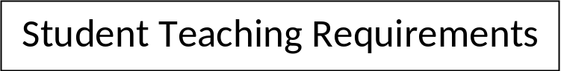

- Attend the Student Teaching Meeting with the Director of the Field Experiences. Attend three additional meetings: Student Teacher/Cooperating Teacher Orientation, midterm and final conference, which are scheduled at the beginning, middle and end of the student teaching semester with the Program Supervisor.
- Follow guidelines listed on the Responsibility Schedule.
- Complete a portfolio which includes all required artifacts. Refer to the “Portfolio Assessment”.
- Complete all required supervisor assignments.
- Follow all requirements listed on the “Midterm” and “Final” assessment.
- Purchase required textbook for TLS 493. Be responsible for reading the current “Student Teacher Guidebook”, which can be found on the College of Education website or purchased at Fast Copy’s website:
https://www.myorderdesk.com/Form.asp?Provider_ID=155862&OrderFormID=305953
- Student teachers are required to provide documentation on a time card. Documentation includes attendance, observations, pass or fail grade, completion of portfolio and other related activities. Time cards are to be signed and completed at the time of the final conference and given to the Program Supervisor. Attendance will be verified by Cooperating Teacher each day and the Program Supervisor will initial the timecard during each visit.
- Student teachers are required to maintain communication with University Supervisor and Cooperating Teacher and to check their U of A email regularly.

18
18

Supervising Practitioner/Cooperating Teacher
Information

Office of Field Experiences

Cooperating/Mentor Teacher Information

Student Teaching Selection Process

Most often, and ideally, teacher candidates return to student teach to a teacher with whom they have worked with during a practicum phase of their program, provided:

- the mentor teacher meets the criteria listed below as verified by the school principal,
- the mentor teacher is willing to serve as a UA cooperating teacher for the capstone experience; this is verified in 1:1 meeting with the UA site coordinator
- the UA student and mentor agree that they have a good working relationship; this is verified in 1:1 meeting by the UA site coordinator

In this way, teacher candidates have two semesters of learning with one mentor teacher. From time to time and for various reasons, a teacher candidate does not return to a previous mentor’s classroom to student teach. When that occurs, the Director of Field Experiences, using the grade level preferences identified by the student teacher, works with school district partners to identify another qualified cooperating teacher for the UA student.

Qualifications

The University of Arizona Cooperating Teacher must:
- Be certified to teach by the Arizona as Department of Education(ADE) and employed as a teacher
- Have a minimum of three years teaching experience relevant to the certificate the candidate is seeking*
- Have a classification of highly effective or effective in his/her teacher evaluation (ASRS statute §15-203A(38) when applicable*
- Have adequate training from the University of Arizona. This is in the form of a 3 hour UA workshop held the semester prior to the teacher candidate’s semester, and it is offered multiple times.*
- Be interested in mentoring student teachers as part of their responsibility to the profession.
- Be capable of working as effective team members with the school administration, university supervisor and the College of Education for the benefit of student teachers
- Be committed to spending time with student teachers in planning and evaluation
19
- Evaluate continuously their own effectiveness as teachers and strive for self-improvement
- Be able to communicate their knowledge of teaching and learning to others
- Demonstrate a positive and enthusiastic attitude toward teaching and working with student teachers Supervising Practitioner/Cooperating
- Be approved to be a cooperating/mentor teacher by their school district and principal
*Requirements as specified by the Arizona Department of Education (R2-604.17)

Supervising Practitioner/Cooperating Teacher Responsibilities

While many of the student teachers have been working with their cooperating teachers prior to student teaching, it is important that all cooperating teachers:

- Acquaint the student teacher with the school, staff, teachers, children, families and community
- Guide unit and lesson planning
- Co-plan and co-teach throughout the semester
- Review all school and classroom policies, regulations, and practices, for example emergency procedures and process for signing children in and out of the school
- Review all documents that teachers use, such as school faculty handbooks, student handbooks, and parent-family handbooks – including emergency procedures and AZ State Mandatory Reporting Law requirements.
- Create an inclusive environment for the student teacher with teachers, staff, families, community, and children
- Include student teacher in school and community events that will support the student teacher’s sense of belonging and will build their knowledge of the children’s lives
- Provide a space for the student teacher to place belongings, resources, and instructional materials
- Inform the student teacher of all state, district and school standards and policies that impact planning
- Provide the student teacher with the goals and objectives for the classroom for the year as well as for the time the student teacher is present
- Model and include as appropriate the student teacher in assessing student performance using the school’s assessment and reporting tools
- Afford opportunities for the student teacher to visit and work with other groups of children or classrooms to expand the student teacher’s understanding of the ways children’s development influences planning
- Promote the student teacher’s professional and personal growth by modeling appropriate behavior and discussing ways in which the student teacher can grow professionally
- Communicate, as soon as possible, any particular concerns regarding the teacher candidate to the university supervisor.
- Communicate any program/personnel concerns, as soon as possible, to the Director of Field Experiences

20

Supervising Practitioner/Cooperating Teacher Feedback

Evaluation as a Continuous Process

Feedback and support from the University Supervisor and cooperating/ mentor teacher is essential. Suggestions, ideas, and strategies will help student teachers to continue to grow throughout their experience.

- The time and location of conferences should be planned in advance, if possible. The setting should be informal and in a location where few interruptions are likely to occur.
- The conferences should be characterized by a free exchange of ideas. It is helpful if many of the topics are problem-centered in terms of seeking answers to methodological or curriculum problems. Alternative solutions to such concerns should be analyzed with both the student teacher and cooperating/mentor teacher offering ideas. The use of video or audio taping can provide data for the conference.
- The conferences should contribute to the student teacher becoming increasingly self-directive and self-reflective.
- Analysis of the student teacher’s performance or personal qualities should achieve an appropriate balance between strengths and areas in need of further development.
- Cooperating/mentor teachers should offer suggestions and learning environment ideas. Student teachers appreciate the time the cooperating/mentor teacher takes to show them instructional materials, curriculum guides, diagnostic and assessment instruments and the modeling of effective instructional strategies.

Daily Conferences
Daily conferences of comparatively short duration will give attention to matters of immediate consequence such as: adjustment of plans, coordination of instruction, the identification and solution of daily issues, and instructional feedback. The timing of such conferences may vary from day to day.

21

Weekly Conferences
Weekly conferences have many uses including: weekly co-planning, cooperative evaluation of the student teacher’s competence and growth, analysis of the classroom teacher’s instructional and classroom management procedures, and development of in-depth understanding of student performance in relation to instruction.

Video Taping
Video and audio recording may be used to as opportunities to self-reflect on professional practice. When recordings are used, student teachers will work with their cooperating/mentor teacher to strictly follow all school and district guidelines.

Conferences with the Program Supervisor
- The initial on-site visit constitutes the first conference.
- Observations usually begin the second week of student teaching and continue every two to three weeks throughout the semester.
- The observations continue and the midterm conference is scheduled to include the student teacher and cooperating teacher/supervising practitioner. At the conference the midterm assessment instrument will be discussed.
- The final conference brings closure to the student teaching experience.

22
Compensation for Supervising Practitioners/Cooperating Teachers

The stipend for hosting a University of Arizona student teacher is five hundred dollars ($500.00) each semester. All cooperating teachers are required to fill out a compensation card at the beginning of each semester. If two cooperating teachers share responsibility for a student teacher, the compensation will be divided equally and each cooperating teacher is required to complete a compensation card. Incomplete cards will delay the payment process.

Stipend requests are processed through the College of Education business office, sent to the Financial Services Office and checks are issued approximately four to six (4 to 6) weeks after the completion of the university academic semester.

Mentor Teachers also earn 30 professional development credit hours that may be used for Arizona State recertification for their work with student teachers.

Important information regarding compensation:

- Cooperating teachers who were employed or terminated by the University of Arizona in the past twelve (12) calendar months must indicate that on the compensation card and are required to complete a Non Competitive Extra Help online application and will receive a payroll check. Indication of the university department is required.
- Social Security numbers are not kept on file and must be provided each term.
- Compensation cannot be processed without a signature or if there is any incomplete or incorrect information.
- If you are not a citizen or national of the United States or a lawful permanent resident, you must present original, valid, unexpired employment documentation to the Office of Field Experiences.
- Cash stipends are taxable income and reported to the Internal Revenue Service.

At the conclusion of the semester, cooperating teachers/supervisory practitioners will also be issued a certificate for 30 hours of professional development credit from the University of Arizona, which may be used for Arizona State Recertification units.
23
23
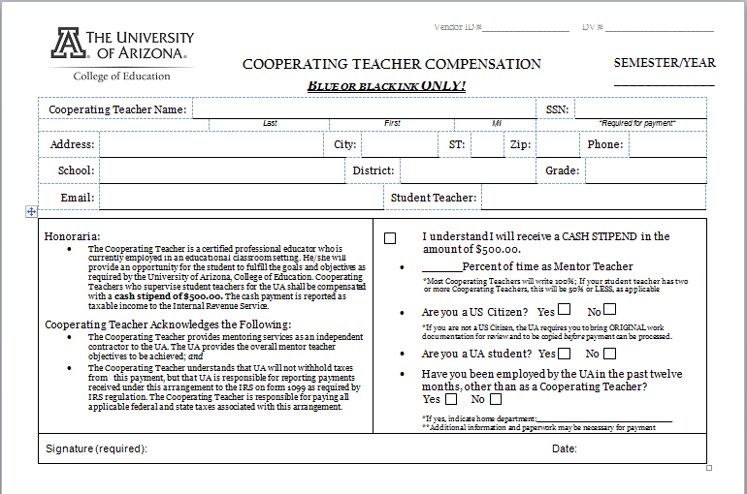



24

University/Program Supervisor Information

Office of Field Experiences

University Supervisors

Qualifications

Supervisors are “Teaching, Learning and Sociocultural Studies Department” full and part time College of Education faculty members, faculty members from specific content area colleges and departments within the University of Arizona, and teachers in residence professors who are master teachers from local school districts.

Program / University Supervisors work together with student teachers and cooperating/mentor teachers to form a valuable support system to assure a successful student teaching experience. University supervisors have expertise at the elementary level and expertise in specific program areas.

Overview of Requirements

Supervision of teacher candidates involves a variety of strategies and assessments. Throughout the required 75 days, supervisors make weekly contacts, which are essential in order to assure two-way communication. Classroom observations are required every two to three weeks, in an ongoing way throughout the semesters, to evaluate the student teacher’s progress in all areas, not just instructional and classroom management strategies. Supervisor seminars are designed to meet the needs of the students throughout the semester. Supervision includes the important element of coaching as one goal of our program is to develop teachers who are reflective practitioners. A variety of assessment instruments are used during the semester. These include: Informal and formal observations, midterm and final conferences involving the Program/University supervisor, Supervising Practitioner/Cooperating Teacher, and teacher candidate, portfolio assessment, and a time card which documents attendance and other requirements. The supervision of teacher candidates is a supportive, informative, and caring process.

25

25
Student Teacher, Mentor/Cooperating Teacher & University Supervisor Three Way Meetings

#1 Initial Meeting/Orientation – This is an orientation meeting which is scheduled with the Supervising Practitioner/Cooperating Teacher and the Teacher Candidate by the Program/University Supervisor. At this meeting, student teaching expectations are reviewed, and the business of coursework is conducted. As an example, at this meeting, supervising practitioners fill out paperwork for their financial compensation. Teacher Candidates may be asked to stay longer than the supervising practitioner to review course requirements in more detail.

#2 Mid-Semester Evaluation Conference – This is the midterm evaluation meeting that is scheduled with the Supervising Practitioner/Cooperating Teacher and the Teacher Candidate by the Program/University Supervisor sometime during the 7th or 8th week of the semester. This is a three way conference; that is, input from the university supervisor, mentor teacher and the student teacher is included in the assessment.

#3 Final Conference – This is the end of the course evaluation meeting that is scheduled with the Supervising Practitioner/Cooperating Teacher and the Student Teacher by the University Supervisor during the last two weeks of the student teaching experience. This is a three way conference; that is, input from the university supervisor, mentor teacher and the student teacher is included in the assessment.

Initial Visit to the Classroom

This visit is scheduled at the beginning of the semester and is the first opportunity for the supervisor to visit the classroom. The supervisor will meet the office staff and if possible the principal. The opportunity to see the classroom “with students” is ideal but not always possible. The student teacher or cooperating/mentor teacher will introduce the supervisor to the classroom and students.

- It is important to find a place in the classroom that can be used for written communication so when supervisors are visiting the school and need to exchange written communication, they will not need to interrupt the instruction. (For example: tray, folder, and counter area)

- This is a good time for the supervisor to be given a school handbook, which will include important practical information such as a map, school calendar, hours, and names of staff.

26

Scheduling

University of Arizona supervisors are not required to schedule observations but it is highly recommended that observations be scheduled. Due to the complicated school and classroom schedules when students may not be in the classroom it is more productive for time management to schedule observation times.

Amount of Time/Written Feedback

The amount of time a University Supervisor spends observing a student teacher in a classroom will depend on the objective of the observation. Early in the semester, the supervisor may drop in to get to know the learning environment and observe the student teacher interact with students and may only stay a short while. As the student assumes a larger role in instruction, the observation time should increase.

Please note that it is very important to schedule some coaching time after each observation, regardless of the amount of time the student was observed. Remember that good teaching includes timely feedback. Supervisors will decide the appropriate amount of time to schedule. For example: 60 minutes of observation with a 50 minute debriefing/coaching. Times vary. Supervisors must provide written feedback to the student teacher within 24 hours of the observation. Many supervisors leave handwritten notes after the observation. Others send feedback summaries electronically. The choice is up to the supervisor.

When the student teacher is in the midst of his/her 20-day full responsibility requirement, it is very important to schedule observations on different days and at different times of day in order to have the opportunity to observe the teacher facilitate learning in different contexts, and use a variety of instructional strategies and classroom management techniques.

It is expected that each teacher candidate will be formally observed a minimum of six times during the semester within every 2-3 weeks.

27
27

Weekly Contacts with Teacher Candidates

Supervisors will make weekly contacts with teacher candidates throughout the semester. This will give supervisors a chance to answer individual questions and establish two-way communication strategies. Weekly contacts may include university meetings, seminars, conferences, e-mail, phone or written communication. Students may be required to keep a journal.

Seminars

Seminars are meetings scheduled by the university supervisors to meet with their assigned student teachers. Student teachers may need to be out of the classroom for a short time to attend these meetings due to scheduling. Seminars are opportunities for teaching and answering student teacher’s questions. As the semester begins, student teachers will have many questions about their requirements, school procedures, classroom management strategies, and scheduling.

Seminars may be combined with other activities. For example: Two supervisors may decide to cover the same topic and want to combine their groups of student teachers or a guest speaker may be scheduled for several groups. The University of Arizona may have certain events or workshops which may be counted as a seminar, with the approval of the supervisor. Sometimes individual school seminars are held due to the number of student teachers in different locations. Seminars are considered one of the “weekly contacts.”

28
28
Office of Field Experiences

Policy for Student Teacher Dismissal/Reassignment

In certain situations, a student may need to be moved to a second teaching assignment or removed totally from student teaching. Difficulties, which the student cannot overcome, such as: personality conflicts, conflicting expectations, excessive absences, inadequate performance, and insurmountable discipline problems are some of the typical causes.

IT IS IMPERATIVE that the University/Program Supervisors identify these difficulties early in the semester and notify the Director of Field Experiences as soon as the problem becomes evident. The following action should be taken without delay:
I. If appropriate, a notice of concern is written and should the issued continue, a professional growth plan will be developed by the university/program supervisor and the supervising practitioner/cooperating teacher, which will be signed by the university supervisor, the supervising practitioner/cooperating teacher, the student teacher at a conference with the Director of Field Experiences.
II. Should the concern continue, despite the professional growth plan, the supervising practitioner/cooperating teacher and the university supervisor will recommend removal from the placement and document the reasons for these recommendations. A recommendation for removal shall be submitted to the Director of Field Experiences. Please note, the school site reserves the right to end the placement at any time. The placement could also end abruptly should a grievous concern arise which necessitates removal.
III. The Program/University supervisor and Director of Field Experiences will:
A. Make a decision regarding withdrawal from student teaching or reassignment of a placement.
B. A conference will be held with the student teacher, university supervisor, and the Director of Field Experiences to discuss the needs and responsibilities of the student teacher and to review the documentation.
- If the reason for removal is justified, and a second placement is an option, a written contract may be drawn up outlining university expectations for future development. In some cases, remediation may be required, and placement will be delayed. The Director of Field Experiences will review the outcome of the remediation experience to determine if a second and final placement will be awarded.
- All second placements are contingent on petition approval.
- If a second placement is approved, this placement will be considered a final placement, and will be approved for the next semester.
- All students will be referred to their academic advisor or the Director of Admissions, Advising and Student Services to discuss their options.
29

Assessment of
Student Teacher Performance

Office of Field Experiences

Assessment of
Teacher Candidate Performance

Grading

The teacher candidate who successfully completes student teaching requirements will receive the grade of “P” (pass) indicating he/she has received the prescribed units of credit for the course. The student who, in the judgment of the cooperating/mentor teacher and university supervisor, has failed to progress sufficiently during the student teaching experience will receive the grade of “F” (fail). Neither a passing nor a failing grade is included in the computation of the graduation grade average. All required materials must be received in the Office of Field Experiences before grades will be posted.

Required Assessments

- Teacher Candidate Midterm/Final Evaluation, which is a performance based instrument.

- Portfolio Assessment: Artifacts contained within support the criteria evaluated on the Teacher Candidate Midterm/Final Evaluation. This portfolio is reviewed and evaluated by Program/University Supervisors

- Teacher Candidate Time Card
The Teacher Candidate Time Card will confirm attendance, observations, supervisor seminars, or conferences and provide documentation of completed requirements.

30
30
Midterm and Final Conference Guidelines

Scheduling: BE PROACTIVE WHEN SCHEDULING
(School district calendars may require adjusting these dates.)

Midterm Conference –

Fall semester and Spring Semester:

Approximately 7 weeks after beginning of student teaching.

Final Conference –

Fall semester: By first week in December

Spring semester: By first week in May

Teacher Candidate Midterm and Final Evaluation

The University of Arizona official form is to be used for these conferences. Midterm and final forms must be signed and returned to the Director of Field Experiences for review and as an official record.
Procedures for Completing University of Arizona Assessment Forms

The Program/University Supervisor, Supervising Practitioner/Cooperating Teacher, and Teacher Candidate will fill out the assessment form once at the midterm and once for the final evaluation. Then, together at a conference with the supervisor, teacher candidate and supervising practitioner, ainput will be combined to create the final midterm report and the final year end report. Note: When consensus cannot be reached in regard to a rubric score or scores, the Program/University Supervisor shall make the final determination. All three signatures and the date must be on each evaluation form. Signatures indicate participation in the process.

31
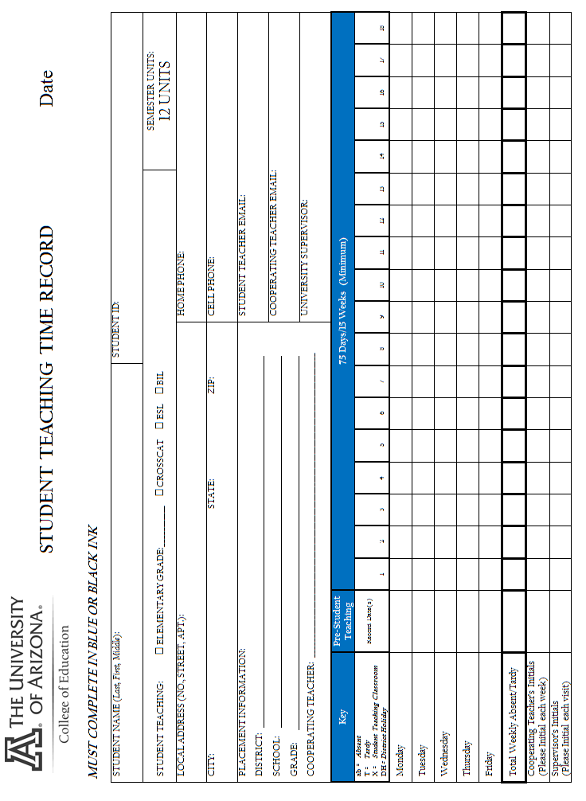
32
32

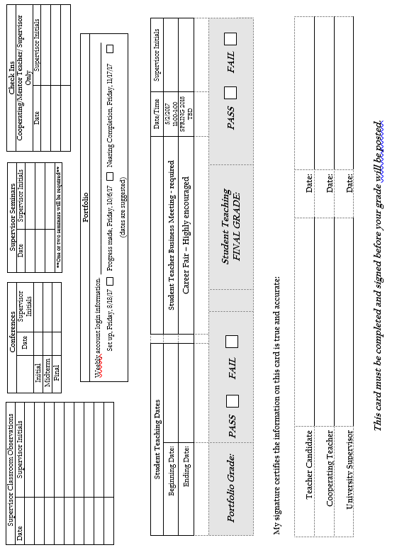
33

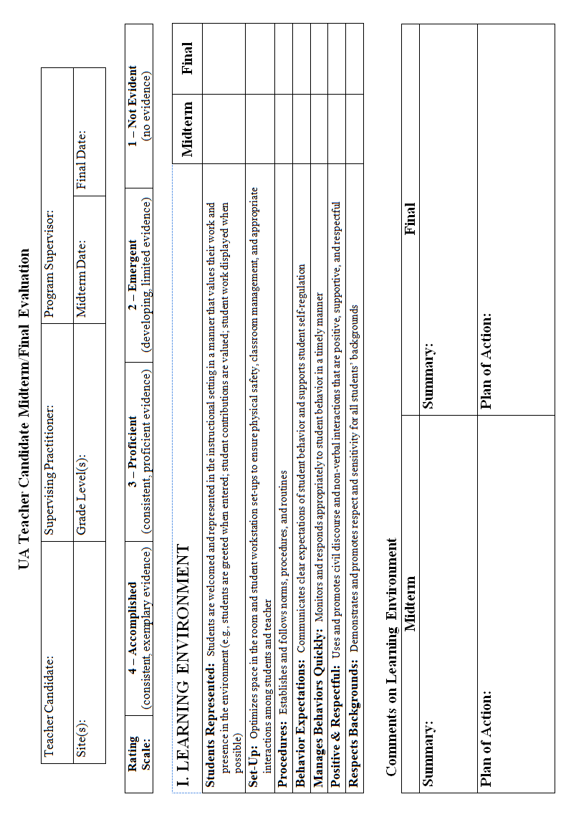
34
36
34
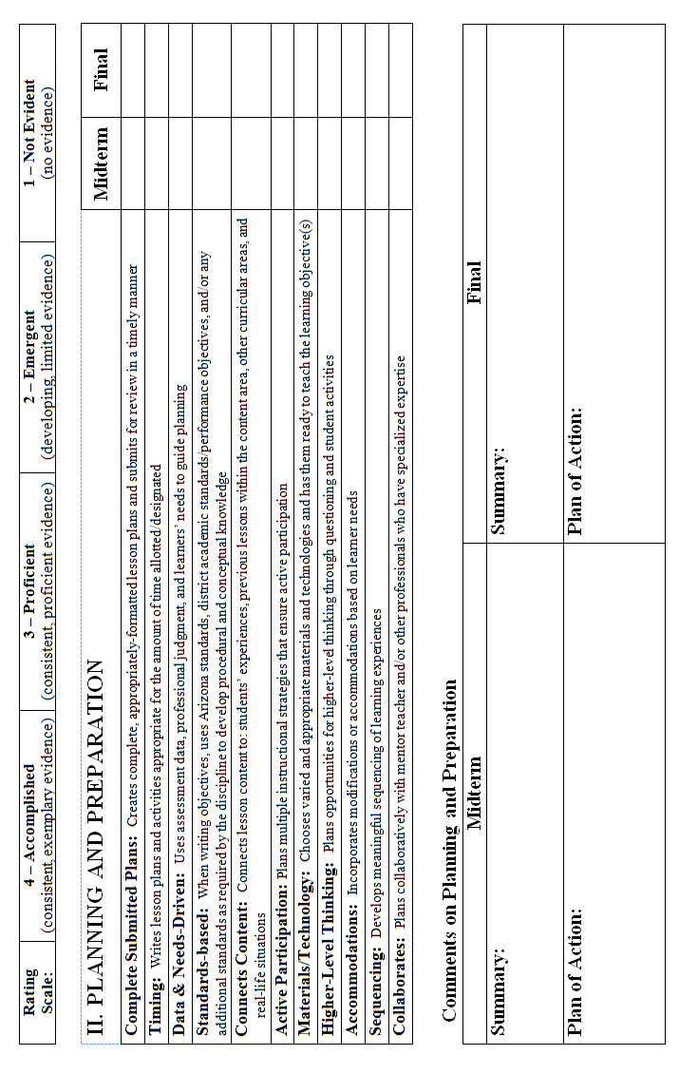
35
35
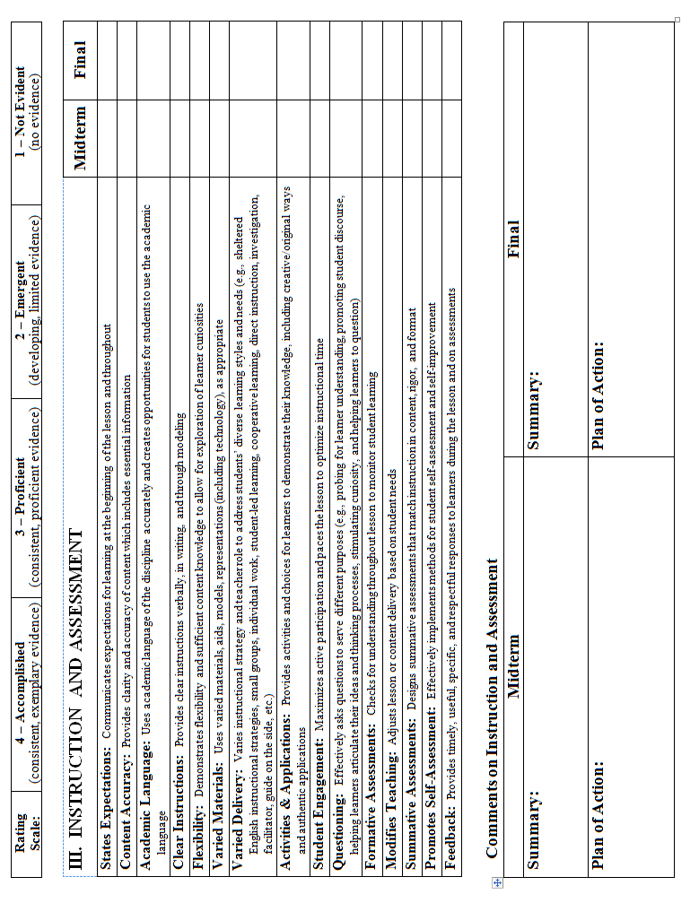
36
37
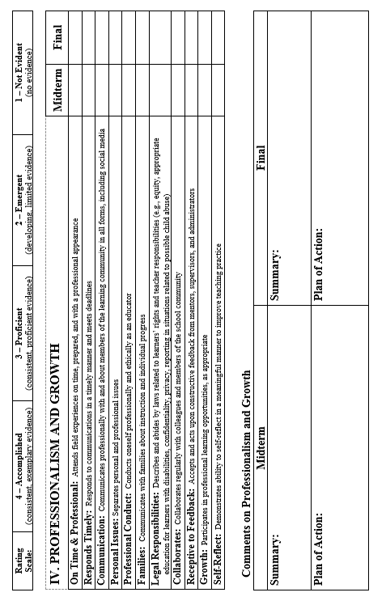
38
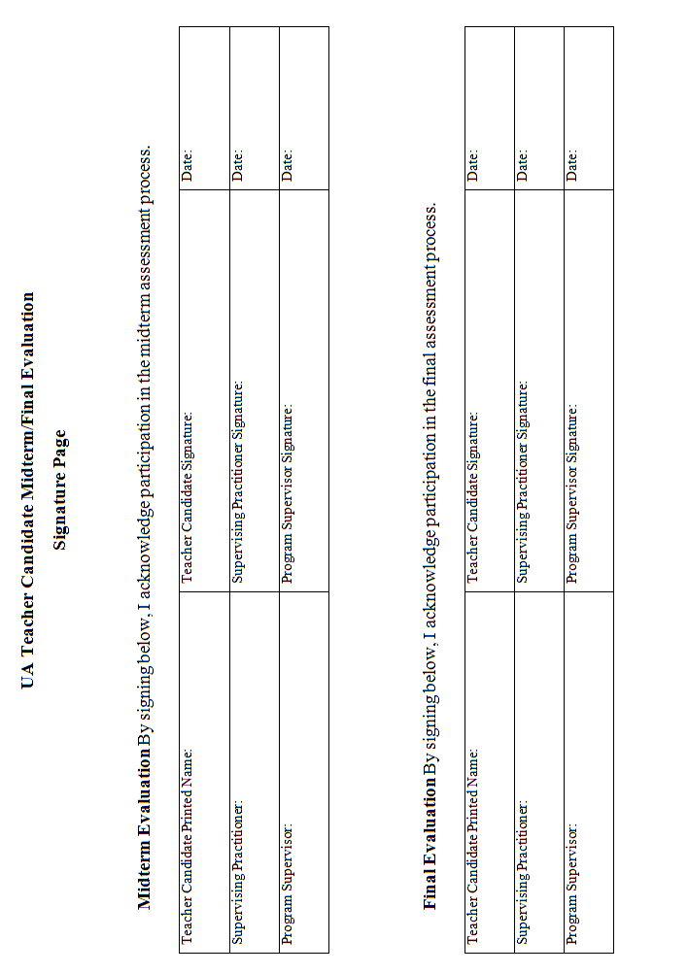
39
39
 | 4 - Accomplished | 3 - Proficient | 2 – Emergent | 1 – Not Evident
Students Represented | Makes effort on a daily basis to make students feel welcome and valued in the educational setting. | Makes effort on most days to make students feel welcome and valued in the educational setting. | Occasionally makes effort to make students feel welcome and valued in the educational setting. | Makes no effort to make students feel welcome and valued in the educational setting.
Set up | Thoughtfully and purposefully manages space to ensure physical safety, classroom management and appropriate interactions among participants. | Makes significant effort to manage space to ensure physical safety, classroom management and appropriate interactions among participants. | Makes some effort to manage space to ensure physical safety, classroom management and appropriate interactions among participants. | Makes no effort to manage space to ensure physical safety, classroom management and appropriate interactions.
Procedures | Establishes and applies clear norms, procedures and routines and consistently reinforces them. | Establishes and applies clear norms procedures and routines and occasionally reinforces them. | Establishes clear norms procedures and routines but does not consistently apply or reinforce them. | Fails to establish or apply clear norms, procedures and routines.
Behavior Expectations | Communicates clear expectations of student behavior and supports student self-regulation. | Communicates clear expectations of student behavior but does not consistently encourage student self-regulation. | Communicates expectations for student behavior but the expectations lack clarity. Opportunities for student self-regulation are not provided | Fails to communicate clear expectations of student behavior.
Manages Behaviors Quickly | Monitors student behavior carefully and responds in a timely and appropriate manner. | Monitors student behavior and usually responds in a timely and appropriate manner. | Monitors student behavior but sometimes responds in an untimely and/or inappropriate manner. | Fails to monitor student behavior and/or routinely responds in an untimely or inappropriate manner
Positive & Respectful | Thoughtfully and purposefully uses and promotes civil discourse and non-verbal interactions that are positive, supportive and respectful. | Often uses and promotes civil discourse and non-verbal interactions that are positive, supportive and respectful. | Sometimes uses and promotes civil discourse and non-verbal interactions that are positive, supportive and respectful. | Fails to use and promote civil discourse and non-verbal interactions that are positive, supportive and respectful.
Respects Background | Consistently demonstrates and promotes respect and sensitivity for all students’ backgrounds. | Usually demonstrates and promotes respect and sensitivity for all students’ backgrounds. | Sometimes demonstrates and promotes respect and sensitivity for all students’ backgrounds. | Fails to demonstrate and promote respect and sensitivity for all students’ backgrounds.
Teacher Candidate Evaluation Rubric
Learning Environment:

40
Teacher Candidate Evaluation Rubric
Planning and Preparation:

41
 | 4 - Accomplished | 3 - Proficient | 2 – Emergent | 1 – Not Evident
Submitted Plans | Plans are consistently and exceptionally well developed, well formatted, and submitted in advance when appropriate. | Plans are consistently well developed, well formatted, and submitted in advance when appropriate. | Plans are sometimes well developed, complete, well formatted, and submitted in advance when appropriate. | Plans are rarely, if ever, well developed, complete, well formatted, and submitted in advance when appropriate.
Timing | Lesson plans are consistently and impeccably commensurate with time allotted and includes time for lesson closure. | Lesson plans are consistently commensurate with time allotted and includes time for lesson closure. | Lesson plans are sometimes commensurate with time allotted and includes time for lesson closure | Lesson plans are rarely, if ever, commensurate with time allotted and includes time for lesson closure
Data & Needs | Lesson planning is consistently driven by student needs as measured by formal and informal assessments. | Lesson planning is often driven by student needs as measured by formal and informal assessments. | Lesson planning is seldom driven by student needs as measured by formal and informal assessments. | Lesson planning is rarely, if ever driven by student needs as measured by formal and informal assessments.
Standards Based | Objectives are consistently based on all appropriate standards required by the discipline, and include language objectives for English Language Learners. | Objectives are consistently based on most standards required by the discipline and include language objectives for English Language Learners. | Objectives are sometimes based on most standards required by the discipline and occasionally include language objectives for English Language Learners. | Objectives are rarely, if ever, based on most standards required by the discipline and do not include language objectives for English Language Learners.
Connects Content | All content is intentionally connected to students’ prior knowledge, experiences and other subject areas. | Content is consistently connected to students’ prior knowledge, or experiences or other subject areas. | Content is sometimes connected to students’ prior knowledge, or experiences or other subject areas. | Content is rarely, if ever, connected to students’ prior knowledge, experiences or other subject areas.
Active Participation | Plans consistently include varied instructional strategies that maximize active student participation. | Plans consistently include varied instructional strategies to ensure some active student participation. | Plans may include some instructional strategies to ensure some active student participation for a part of the time. | Plans rarely, if ever, include instructional strategies to ensure some active student participation for a part of the time.  .
Materials/Technology | Varied and appropriate materials are customized to support the learning objective(s). Materials are easily accessible and always ready. | Varied and appropriate materials are used to support the learning objective(s).  Materials are accessible and always ready. | Varied and appropriate materials are sometimes used to support learning objective(s). Materials are generally accessible and ready. | The varied use of appropriate materials is rarely, if ever, supports the learning objective(s). Materials are not often easily accessible or ready.
Higher Level Thinking | Lesson plans include activities and planned/intentional questioning that consistently promote ongoing higher level thinking. | Lesson plans include activities and planned/intentional questioning that often promote high level thinking. | Lesson plans include activities and planned/intentional questioning that sometimes promote high level thinking. | Lesson plans include activities and planned/intentional questioning that rarely, if ever, promote high level thinking.
Accommodations | All learner needs are consistently met with appropriate accommodations and modifications. | All learner needs are often met with appropriate accommodations and modifications. | Learner needs are sometimes met with appropriate accommodations and modifications. | Learner needs are rarely, if ever, met with appropriate accommodations and modifications.
Sequencing | Lessons are extremely well sequenced. | Lessons are appropriately sequenced. | Lessons are, for the most part, appropriately sequenced, but in- lesson transitions could be improved. | Lessons are delivered without appropriate sequencing.
Collaborates | Collaborates consistently with mentor teacher and other professionals when planning to improve lesson quality and meet learner needs. | Collaborates often with mentor teacher and other professionals when planning to improve lesson quality and meet learner needs. | Collaborates on occasion with mentor teacher and other professionals when planning to improve lesson quality and meet learner needs. | Collaborates, seldom, if ever, with mentor teacher and other professionals when planning to improve lesson quality and meet learner needs.

42
Teacher Candidate Evaluation Rubric
Instruction and Assessment:

43
 | 4 - Accomplished | 3 - Proficient | 2 – Emergent | 1 – Not Evident
States Expectations | Communicates learning expectations and outcomes in a consistent, effective, and meaningful way at the beginning of the lesson and throughout. | Communicates expectations for learning at the beginning of the lesson and throughout. | Learning expectations may be poorly communicated and/or not referenced throughout the lesson | Expectations for the lesson are not communicated.
Content Accuracy | Content knowledge is accurate and can be explained in multiple, accurate manners and applications. Essential information is included and emphasized during the lesson. | Content knowledge is accurate and essential information is emphasized. | Teacher may not teach the essential information accurately or might spend too long focusing on non-essential information. | Incorrect information is periodically given. Teacher does not demonstrate sufficient content knowledge to distinguish essential information.
Academic Language | Demonstrates mastery of the discipline’s academic language and creates multiple opportunities for students to easily and accurately use the academic language. | Uses academic language of the discipline accurately and creates opportunities for students to use the academic language. | Academic language is sometimes used. There may be few opportunities for students to practice the academic language. | Academic language is unused or used inaccurately and/or student misuse of the language goes uncorrected. There may be little to no opportunities for students to practice the academic language.
Clear Instructions | Instructions are provided clearly and in multiple ways (including verbally, written, and through modeling) prior to activities, resulting in student understanding of the instructions. | Provides clear instructions verbally, in writing, and through modeling. | Instructions may not be clear to the students and need to be repeated numerous times for student understanding. | Instructions are either not provided or only provided in one method.
Flexibility | Consistently demonstrates flexibility and advanced content knowledge to allow for explorations of learner curiosities in a manner that still addresses learning objectives. | Often demonstrates flexibility and sufficient content knowledge to allow for exploration of learner curiosities. | Sometimes demonstrates flexibility and sufficient content knowledge to allow for exploration of learner curiosities. | Rarely demonstrates flexibility or sufficient content knowledge to allow for exploration of learner curiosities or any deviations from the lesson plan.
Varied Materials | Regularly integrates varied, engaging, and well-made materials, aids, models, and representations, including technology. | Uses varied materials, aids, models, technology, and representations, as appropriate to the lesson. | Sometimes uses varied materials, aids, models, and representations (including technology), as appropriate. | Rarely uses varied materials and/or materials may not be relevant or effective.
Varied Delivery | Effectively and seamlessly varies instructional strategies and teacher role (e.g., sheltered English instructional strategies, small groups, individual work, student-led learning, cooperative learning, direct instruction, investigation, facilitator, guide on the side, etc.) so that students are engaged in multiple, meaningful methods of learning which address students’ diverse learning styles and needs. | Often varies instructional strategy and teacher role throughout the lesson to address students’ diverse learning styles and needs (e.g., sheltered English instructional strategies, small groups, individual work, student-led learning, cooperative learning, direct instruction, investigation, facilitator, guide on the side, etc.). | Sometimes or ineffectively varies instructional strategy and teacher role throughout the lesson to address students’ diverse learning styles and needs (e.g., sheltered English instructional strategies, small groups, individual work, student-led learning, cooperative learning, direct instruction, investigation, facilitator, guide on the side, etc.). | Seldom varies instructional strategy and teacher role throughout the lesson to address students’ diverse learning styles and needs.
Activities & Applications | Provides varied, relevant and engaging activities and choices for learners to demonstrate their knowledge, including creative/original ways and authentic applications. | Often provides relevant activities and choices for learners to demonstrate their knowledge, including creative/original ways and authentic applications. | Sometimes provides activities and choices for learners to demonstrate their knowledge, including creative/original ways and authentic applications. | Rarely provides activities or choices for learners to demonstrate their knowledge, including creative/original ways and authentic applications.
Student Engagement | Maximizes active participation and paces the lesson to optimize instructional time so that all students are engaged 100% of the time (“bell-to-bell” student engagement). | Students are actively participating for the majority of the lesson and teacher candidate paces the lesson to optimize instructional time. Off task behavior is seldom. | All or most students are engaged for a portion of the lessons. Off task behavior is frequent. Pacing may be too slow or too fast for student understanding and successful performance. | Students are often or always off task.
Questioning | Effectively asks relevant questions that students consistently answer throughout lesson to promote ongoing higher-level thinking and serve multiple purposes (e.g., probing for learner understanding, promoting student discourse, helping learners articulate their ideas and thinking processes, stimulating curiosity, and helping learners to question). | Effectively asks relevant questions to promote higher-level thinking and serve different purposes (e.g., probing for learner understanding, promoting student discourse, helping learners articulate their ideas and thinking processes, stimulating curiosity, and helping learners to question). | Asks questions that sometimes promote high level thinking and serve different purposes, but questions may not be relevant or effective at eliciting student responses. | Rarely asks questions throughout the lesson.
Formative Assessments | Consistently checks for understanding throughout lesson to monitor student learning using varied, engaging, and time-efficient methods of assessment. | Often checks for understanding throughout lesson to monitor student learning using varied and time-efficient methods of assessment. | Sometimes checks for understanding to monitor student learning; these checks may not be varied, scattered throughout the lesson, and/or time-efficient. | Rarely effectively checks for understanding throughout lesson to monitor student learning.  44
Modifies Teaching | As a result of monitoring, consistently adjusts content delivery or lesson plan to maximize student learning. | Often adjusts lesson or content delivery based on student needs. | Sometimes adjusts lesson or content delivery based on student needs. | Rarely adjusts lesson or content delivery based on student needs.
Summative Assessments | Summative assessments are customized to match instruction in content, rigor, and format. | Designs summative assessments that often match instruction in content, rigor, and format. | Designs summative assessments that sometimes match instruction in content, rigor, and/or format. May only use pre-made summative assessments without the opportunity to design assessments. | Does not create or use summative assessments that match instruction in content, rigor, and/or format.
Promotes Self-Assessment | Consistently implements effective, accurate, and useful methods for student self-assessment and self-improvement. | Promotes useful and accurate student self-assessment and self-improvement. | Allows for student self-assessment and self-improvement, but opportunities may not be useful or frequent enough to be effective. | Rarely allows for useful and accurate student self-assessment and self-improvement.
Feedback | Through written and verbal feedback during the lesson and on assignments/ assessments, provides timely, useful, specific, and respectful responses to learners resulting in improvements in student performance. | Through written and verbal feedback, provides timely, useful, specific, and respectful responses to learners. | Sometimes provides timely, useful, specific, and respectful responses to learners. | Rarely provides timely, useful, specific, and respectful responses to learners.

45
Teacher Candidate Evaluation Rubric
Instruction and Assessment:

46
 | 4 - Accomplished | 3 - Proficient | 2 – Emergent | 1 – Not Evident
On Time & Professional | Consistently attends field experiences on time, arrives early and/or stays late so as to be prepared.  Maintains a very professional appearance. | Attends field experiences on time, prepared, and with a professional appearance. | Is, on occasion, late or unprepared for field experience and/or occasionally fails to maintain a professional appearance. | Is often late or unprepared for field experience and/or often fails to maintain a professional appearance.
Responds Timely | In addition to timely communication, anticipates and initiates needed communication, and is prepared in advance of deadlines. | Consistently responds to communications in a timely manner and meets deadlines. | Often responds to communications in a timely manner and meets deadlines. | Seldom, if ever responds to communications in a timely way and/or rarely meets deadlines.
Communication  (includes social media) | Communicates in a highly professional manner with and about the members of the learning community. | Communicates professionally with and about members of the learning community. | Usually but not always communicates professionally with and about members of the learning community. | Does not exhibit professional communication with and about the members of the learning community.
Personal Issues | Consistently and consciously separates personal and professional issues. | Separates personal and professional issues. | Has demonstrated some ability to separate personal and professional issues. | Is unable, at this time, to separate personal and professional issues.
Professional Conduct | Conducts oneself professionally and ethically as an educator. Could serve as a model of professionalism and ethics. | Conducts oneself professionally and ethically as an educator. | Has demonstrated some ability to conduct oneself professionally and ethically as an educator. | There is no evidence for conduct that is professional and ethical.
Families | Builds relationships with families and communicates with families about instruction and individual progress in an ongoing way. | Communicates with families about instruction and individual progress. | Has made an attempt to communicate with families about instruction and individual progress. | There is no evidence of communication with families about instruction and individual progress.
Legal Responsibilities | Describes and abides by laws related to learners’ rights and teacher responsibilities (e.g., equity, appropriate education for learners with disabilities, confidentiality, privacy, reporting in situations related to possible child abuse). | << | >> | Cannot describe and does not abide by laws related to learners’ rights and teacher responsibilities (e.g., equity, appropriate education for learners with disabilities, confidentiality, privacy, reporting in situations related to possible child abuse).
Collaborates | Consistently collaborates with colleagues and members of the learning community in an ongoing way, makes solid contributions to the collaborative efforts, and fosters an interdependence among colleagues. | Collaborates regularly with colleagues and members of the school community. | There is some evidence of collaboration with colleagues and members of the school community. | There is no evidence of collaboration with colleagues and members of the school community.
Receptive to Feedback | Regularly requests, accepts and acts upon constructive feedback from mentors, supervisors and administrators. | Accepts and acts upon constructive feedback from mentors, supervisors, and administrators. | There is some evidence demonstrating acceptance of feedback and action taken as a result of that feedback. | There is little to no evidence that the student  Accepts and acts upon constructive feedback from mentors, supervisors, and administrators.
Growth | Seeks out and participates in professional learning opportunities beyond expectations. | Participates in professional learning opportunities, as appropriate. | Participation in professional learning is minimal. | Does not participate in professional learning.
Self-Reflect | Consistently demonstrates the ability to self-reflect in a deep and meaningful manner about teaching practice and steps needed to improve. | Demonstrates ability to self-reflect in a meaningful manner to improve teaching practice. | Demonstrates some ability to self-reflect in a manner meaningful and may have limited ability to identify steps to improve teaching practice. | There is little to no evidence of meaningful self-reflection and ability to identify steps to improve teaching practice.
47

Student Teacher Portfolio Criteria - Fall 2017

The criteria listed below detail the criteria that are to be included in each teacher candidate’s electronic portfolio. These criteria have been selected from the student teacher evaluation instrument and have been set as the minimum number of criteria to complete the portfolio.

Portfolio artifacts include evidence that the teacher candidate:

Learner Environment:___________________________________________________
National Board for Professional Teaching Standards

Proposition 1: Teachers are committed to students and their learning.

- Welcomes and represents students in the instructional setting in a manner that values their work and presence in the environment
- Demonstrates and promotes respect and sensitivity for all students’ backgrounds

Planning and Preparation:________________________________________________

- Uses assessment data , professional judgement, and learners’ needs to guide planning
National Board for Professional Teaching Standards

Proposition 1: Teachers are committed to students and their learning.
Proposition 2: Teachers know the subjects they teach and how to teach those subjects to students.
Proposition 3: Teachers are responsible for managing and monitoring student learning.

- Connects lesson content to students’ experiences, previous lessons within the content area, and other curricular areas and real-life situations
- Plans multiple instructional strategies that ensure active participation
- Incorporates modifications or accommodations based on learner needs

Instruction and Assessment: _________________________________________

- Uses academic language of the discipline accurately and creates opportunities for students to use the academic language
National Board for Professional Teaching Standards

Proposition 1: Teachers are committed to students and their learning.
Proposition 2: Teachers know the subjects they teach and how to teach those subjects to students.
Proposition 3: Teachers are responsible for managing and monitoring student learning.

- Varies instructional strategy and teacher role to address students’ diverse learning styles and needs
- Provides methods, activities, and choices for learners to demonstrate their knowledge, including creative/original ways and authentic applications
- Checks for understanding throughout the lesson to monitor student learning
- Provides timely, useful, specific and respectful responses to learners while instructing and assessing.

Professionalism and Growth: ________________________________________
National Board for Professional Teaching Standards

Proposition 4: Teachers think systematically about their practice and learn from their experience.
Proposition 5: Teachers are members of learning communities.
- Communicates professionally with and about members of the learning community
- Communicates with families about instruction and individual progress
- Demonstrates ability to self-reflect in a meaningful manner to improve teaching practice
NOTE: Evidence of proficiency in the 14 criteria listed above in the portfolio is a minimum. Please feel free to add other work of which you are proud in a way that reflects your identity and competency as a teacher.

48

