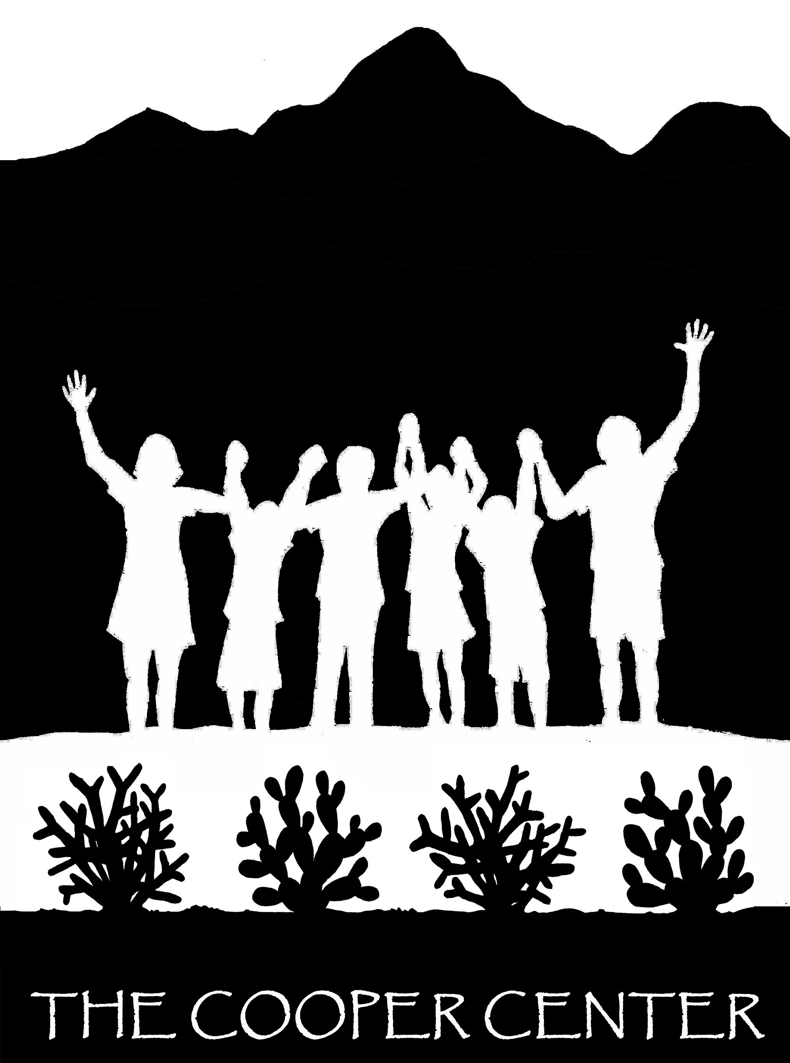
Cooper Center for Environmental Learning
“A University of Arizona and Tucson Unified School District Partnership”

Environmental Learning Internships, 2014-2015 Academic Year
Job Description: Outdoor environmental teaching positions include working with students K-8 from Southern Arizona public and private schools to encourage the hands-on learning and exploration of the Sonoran Desert. Training is provided based on the Cooper Center’s Mission Statement and the ideals of the Institute for Earth Education in order to “emphasize understanding of basic ecological processes, develop positive feelings for the natural world, and make personal lifestyle changes.”

Duties:
- Lead and assist several educational programs in outdoor settings (program training provided).
  - Sunship III (Grades 6-8): This 3 day, 2 night program gives middle schoolers experiences that allow them to personally connect with the natural world and gain knowledge of how their life choices can impact it. This program is a coming of age celebration that offers each student a chance to make decisions and take responsibility for their choices and actions. Program components focus on energy flow, cycling of materials, interrelationships in nature, finding natural beauty, and the impacts of humans on the planet Earth. Program runs October – December.
  - Earthkeepers (Grades 4-5): This 3 day, 2 night program gives upper elementary students the opportunity to gain knowledge about how the Earth functions and to experience the wonders of the desert, earning keys to unlock secrets along the way. Program components focus on energy flow, cycling of materials, interrelationships, and change over time. Program runs January through March.
  - Day programs (Grades K-8): On these days, teaching duties will occur during the morning and early afternoon with the later afternoon left for other center responsibilities. Each grade level has differentiated curriculum. Examples include discovery and exploration of the Sonoran Desert, basic ecological concepts, understanding ecosystems, and plant and animal adaptations for survival. Programs run September through October and March through May.
- Assist in facility maintenance (picking up trash, cleaning, etc.)
- Participate in program-related tasks including planning, setup, materials design and maintenance.
- Assist with field experience logistics including group arrivals and departures and managing students and adults during trips.

Qualifications:
- Required: Enthusiasm, eagerness to help students learn about the natural world, strong communication skills, a positive attitude, ability to work hard as part of a team and independently, physical conditioning and love for working outdoors in a desert setting.
- Preferred: Pursuing a career in Environmental Learning, Education, or a related field; teaching experience; a flair for being theatrical.

Position Specifics:
- Fall Internships begin September 14th, 2015 and continue through the end of the semester.
- Spring Internships begin January 4th, 2015 and continue through the end of the semester.
- Time Commitment: 135 hours per 3-credit internship. Schedule is mainly Monday through Friday with some weekend events. Hours of instruction are flexible.
- Intern reports to Cooper’s Director or Program Coordinator.

*For more information, visit the Cooper Center website or contact Cooper’s Director, Colin Waite, at cwaite@email.arizona.edu or by phone at 520-626-1825.

